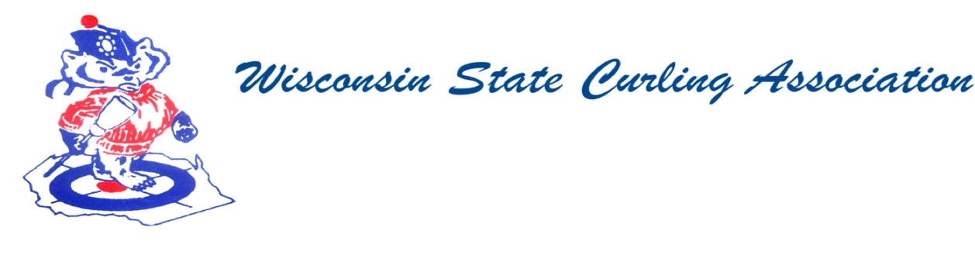

Wisconsin State Curling Association Board of Directors

Saturday, Oct. 3, 2020, 8:00am

Zoom Conference Call  
<https://jamf.zoom.us/j/98513652067?pwd=YitHWUJKbmo5NnhVWENieDJKWDlNQT09>  
Toll Free: 888 475 4499  
Meeting ID: 985 1365 2067  
Passcode: 918307  
One tap mobile  
+18884754499,,98513652067#  
Meeting ID: 985 1365 2067  
Passcode: 918307

**Agenda**

1. Call to Order
2. Roll Call (Kampen)
3. Approval of Minutes (Kampen)
4. Treasurer’s Report (Dunlop)
5. President Report (Lilla)
6. USCA Directors’ Report (Perry)
7. WCF Report (Lepping)
8. Committee Reports
   1. Rules (Maskel)
   2. Website (Hartman)
   3. Bylaws (Russell)
9. Competition
   1. Juniors (Wendling)
   2. Mixed and Men’s and Women’s (Mossberger)
   3. Seniors (Molter)
   4. High School (Wendling)
10. New Business
    1. COVID-19 Updates
    2. WSCA Dues
    3. WSCA Grant
    4. USCA Director
       1. Stipend
       2. Spring Election
11. Next Meeting date and location
12. Adjourn

**PRESIDENT**

Dan Lilla

(608) 484-0509

lillaroad@aol.com

**VICE PRESIDENT**

Terri Gleason

(608) 575-0457

mntgleason@gmail.com

**VP - PLAYDOWNS**

Irv Mossberger Jr.

(218) 260-7458

imossberger@barr.com

**SECRETARY**

Vietta Kampen

(608) 697-6510

vkkampen@gmail.com

**TREASURER**

Greg Dunlop

(414) 708-5683

gdunlop1@hotmail.com

**PAST PRESIDENT**

Sam Johnson

(715) 559-1950

sam@curlingclub.com

**USCA DIRECTOR**

Garret Perry

(608) 358-6344

gqperry@gmail.com