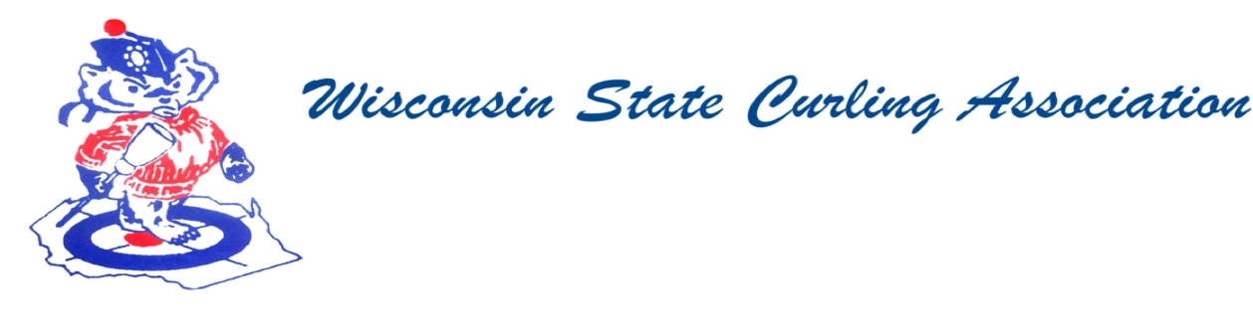

Wisconsin State Curling Association Board of Directors

Saturday, Oct. 9, 2020, 8:00am

Zoom Conference Call

https://jamf.zoom.us/j/92081007495?pwd=ZVAvVWhKTHMrdFY0YVFWcHd1VU9ZQT09

888 475 4499 US Toll-free

Meeting ID: 920 8100 7495

Passcode: 464563

**Agenda**

1. Call to Order
2. Roll Call (Kampen)
3. Approval of Minutes (Kampen)
4. Treasurer’s Report (Dunlop)
5. President Report (Lilla)
6. USCA Directors’ Report (Gleason)
7. WCF Report
8. Committee Reports
   1. Rules (Maskel)
   2. Website (Hartman)
   3. Bylaws (Russell)
9. Competition
   1. Juniors (Wendling)
   2. Mixed and Men’s and Women’s (Mossberger)
   3. Seniors (Molter)
   4. High School (Wendling)
10. Old Business
    1. COVID-19 Updates
    2. WSCA Dues
    3. WSCA Grant
    4. USCA Director Stipend
11. New Business
    1. Spring Election
    2. Need 2022 WSCA Service Award Nominations
12. Next Meeting date and location
13. Adjourn

**PRESIDENT**

Dan Lilla

(608) 484-0509

lillaroad@aol.com

**VICE PRESIDENT**

Terri Gleason

(608) 575-0457

mntgleason@gmail.com

**VP - PLAYDOWNS**

Irv Mossberger Jr.

(218) 260-7458

imossberger@barr.com

**SECRETARY**

Vietta Kampen

(608) 697-6510

vkkampen@gmail.com

**TREASURER**

Greg Dunlop

(414) 708-5683

gdunlop1@hotmail.com

**PAST PRESIDENT**

Sam Johnson

(715) 559-1950

sam@curlingclub.com

**USCA DIRECTOR**

Terri Gleason

(608) 575-0457

mntgleason@gmail.com